Data Flow Diagrams:

Project Design Phase-II

Data Flow Diagram & User Stories

Date | 01 February 2026
Team ID | LTVIP2026TMIDS24102
Project Name | Heritage treasures: an in-depth analysis of UNESCO world heritage sites
Maximum Marks | 3 Marks

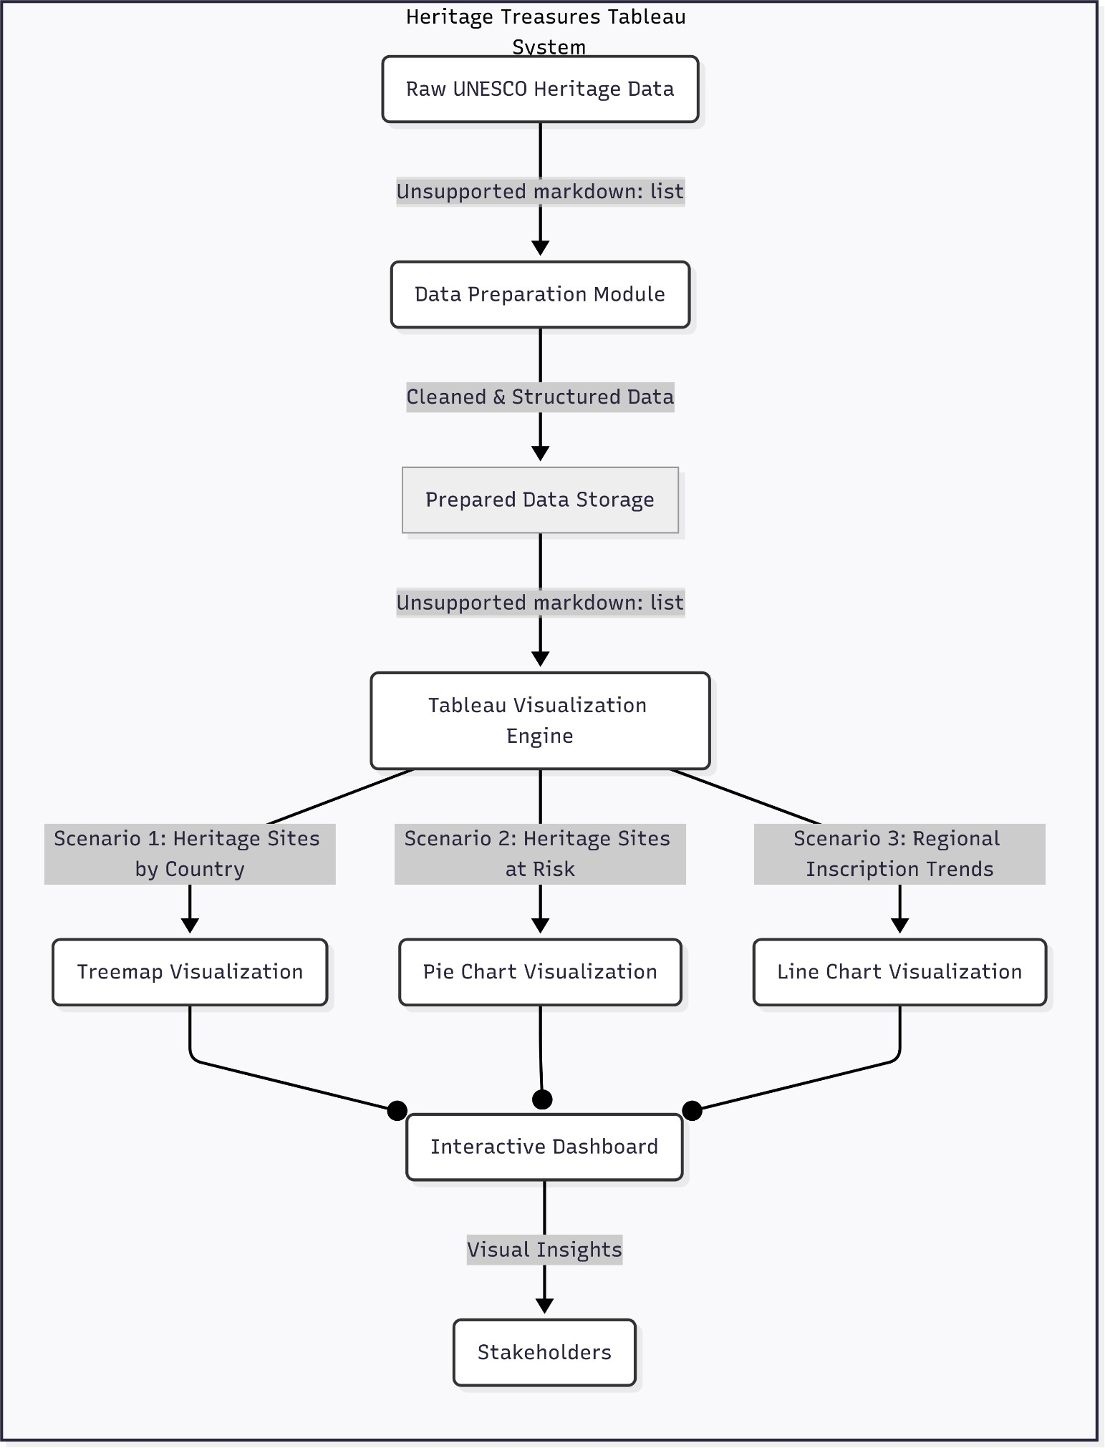

Here’s a User Stories Table for "Heritage Treasures: An In-Depth Analysis of UNESCO World Heritage Sites in Tableau"
